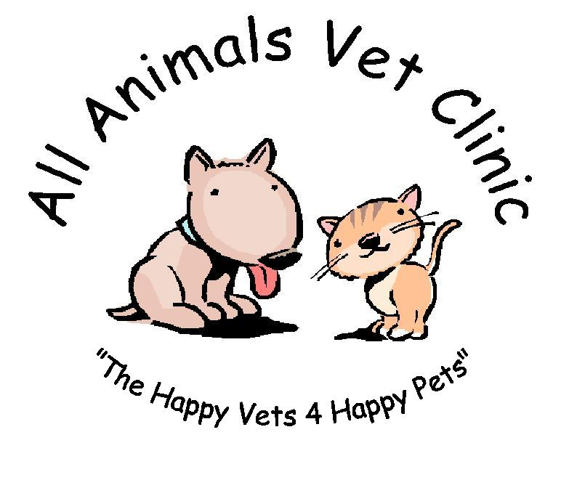

A Message To Our Clients…

Following recent reports of vets over vaccinating dogs; we would like to reassure our clients that we only vaccinate against diseases as is absolutely necessary. We only vaccinate against all the viruses ever 3 years and use a ‘mini’ vaccine in the interim 2 years. This is because your dog maintains immunity against most of the viruses for 3 years but please do realize that this is not the case for every virus and the annual vaccination and health check is essential to keep your pet healthy. Please call the surgery for an information fact sheet to be sent to you.
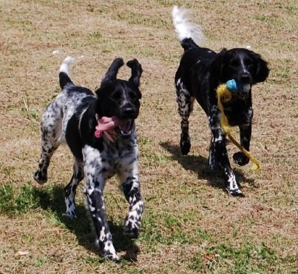

All Animals Vet Clinic,
Unit T, Viking House, Daneholes Roundabout, Grays, Essex, RM16 2XE.

Tel: 01375 399033

Email: allanimalsvetclinic@hotmail.co.uk

Web: www.allanimalsvetclinic.co.uk

